Problem Statement

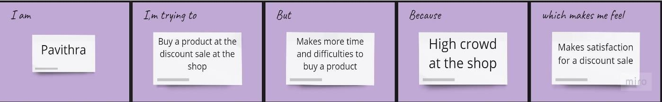 Problem Statement 1:

Problem statement 2:

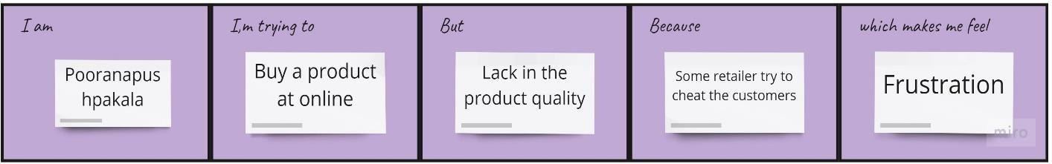

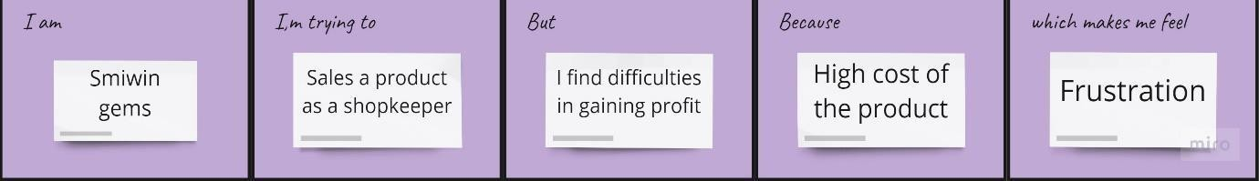Problem statement 3:

Problem statement 4:

